

**School of Information Technology**

Course : Diploma in Business Informatics

Subject : ITP282 - Enterprise Application Development & Project

AY / Sem : 2018 S2

## Lab 2b: Web Application Development with ASP.NET and C#

### OBJECTIVES:

By the end of this Practical students should be able to:

* Create an ASP.NET Web Application
* Code the logic for the application using C#

**Exercise 1: Creating a Temperature Conversion Application**

Your challenge is to create a simple ASP.NET Web Site that allows the user to convert between Fahrenheit and Celsius temperatures. It should look something like this:

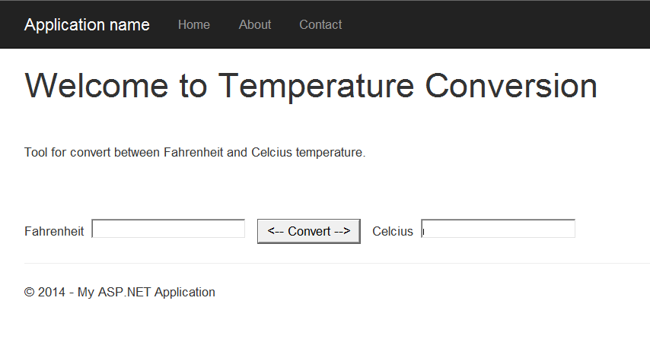

The formula for converting is as follows:

C = (F – 32) / 1.8

F = (C * 1.8) + 32

**Hint:** to convert the text value from each textbox, use the built-in Convert static functions in C#, for example: double nFahr = Convert.ToDouble(this.TextBox1.Text);

* 1. Start Visual Studio 2015 and Select File->New->Web Site

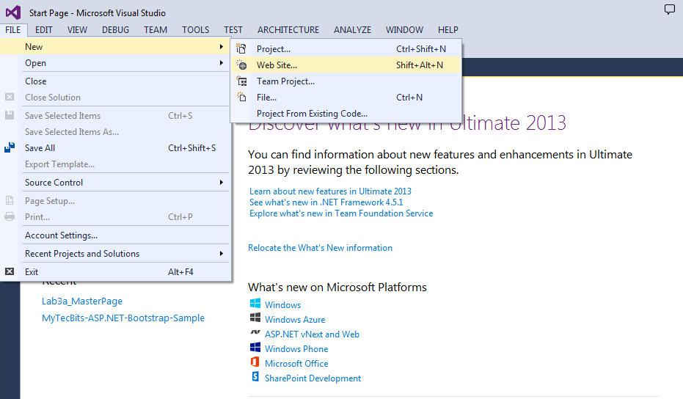

* 1. Choose ASP.NET Web Forms Site and name the web site as **Lab2b**. Click OK.

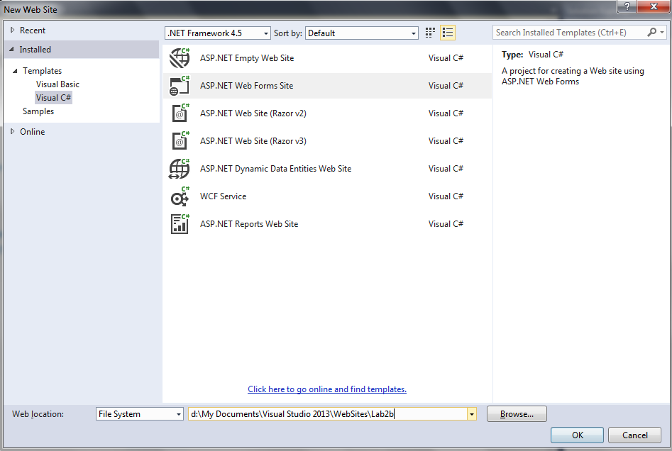

* 1. Switch to Design view by clicking on Design Tab in Document Window. Drag and drop the controls as shown.

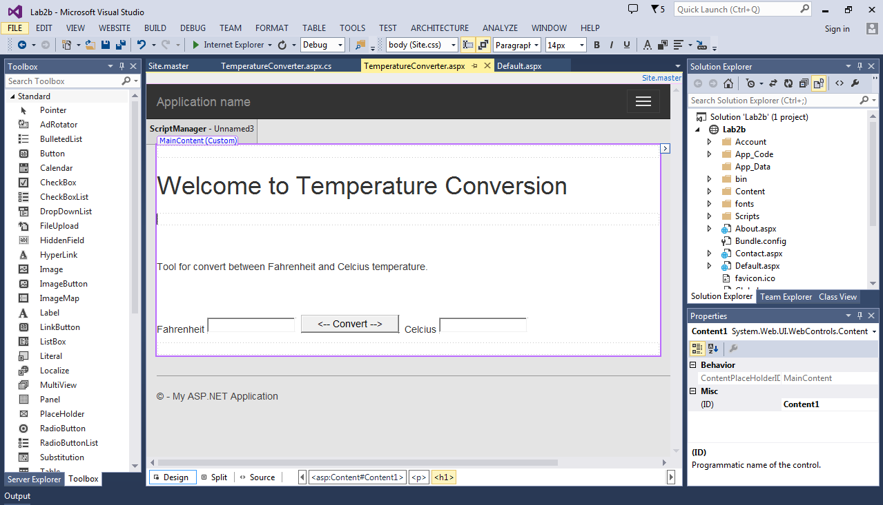

Click each control individually and change their properties from the Property Window as follows:

|  |  |  |
| --- | --- | --- |
| Control | ID | Text |
| Label | lblFahrenheit | Fahrenheit |
| Textbox | txtFahrenheit | <blank> |
| Button | btnConvert | 🡨Cenvert 🡪 |
| Label | lblCelsius | Celsius |
| Textbox | txtCelsius | <blank> |

* 1. To start writing codes to handle the Button Click event, double click on “btnConvert”.
  2. Enter the codes to perform the conversion using the concepts taught in lecture.

Guide for **Exercise: Creating a Temperature Conversion Application**

|  |
| --- |
| protected void btnConvert_Click(object sender, EventArgs e)  {  // Check the Fahrenheit box first  string strFahTemp = this.txtFahrenheit.Text;  if (strFahTemp != "")  {  // Convert from Fahrenheit to Celsius  …  …  // Display the result in the Celsius box:  }  else  {  // Check the Celsius box  string strCelTemp = this.txtCelsius.Text;  if (strCelTemp != "")  {  // Convert from Celsius to Fahrenheit  …  // Display the result in the Celsius box:  …  }  }  } |

* 1. Run the application, you should be able to see the result similar to the following:



**Exercise 2: BMI Calculator**

Create a web page that helps the user to calculate his/her BMI.

The Body Mass Index (BMI) of a person is based on the formula:

BMI = weight (kg) / ( height (m) x height (m) )

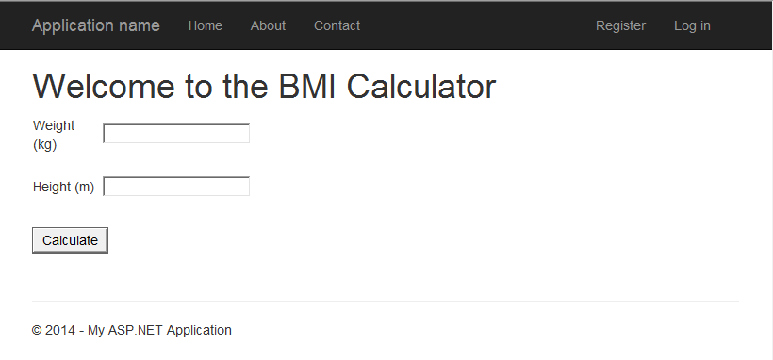

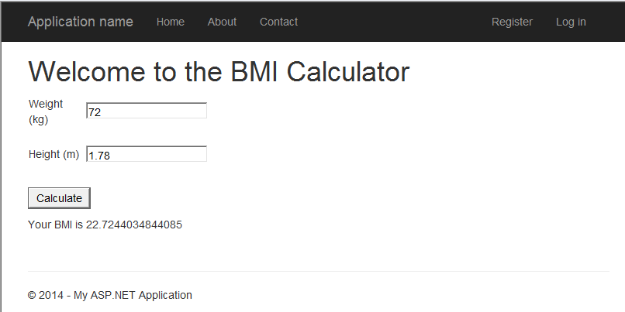

Optional: To include a button named as “Clear”, which will clear the input in the **textboxes** and the displayed text of **label**.

Modify the BMI Calculator to indicate which category the user belongs to. Add a label lbRemarks to your program to accommodate the output.

BMI Categories are shown in the table below.

|  |  |
| --- | --- |
| **BMI Range** | **Category** |
| < 18.5 | Underweight |
| 18.5 – 24.9 | Normal Weight |
| 25.0 – 29.9 | Overweight |
| >= 30 | Obesity |

Guide for **Exercise: BMI Calculator**

// Determine BMI category

string remarks;

if (fBMI < 18.5)

lbRemarks.Text = "You are underweight";

else if (fBMI >= ____ && fBMI < ____)

lbRemarks.Text = "Your BMI is normal and you are doing great";

else if (______________________)

lbRemarks.Text = "You are overweight";

else

lbRemarks.Text = "You are obese! You've got to watch your weight";

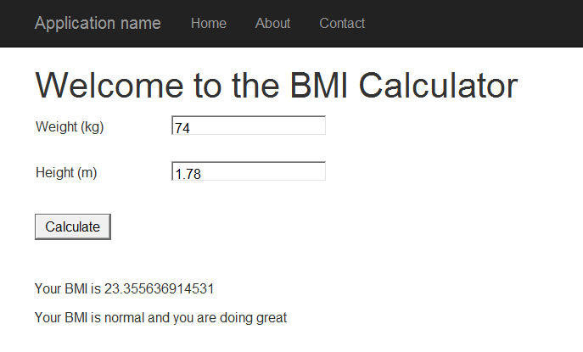

**========== End ==========**